GSM Adobe Commerce
B2B Fulfilment Log Tracking Plan
Tracking and tagging plan for the Girl Scout Merchandise website on the Adobe Commerce platform.
Version: 2026-05-15
Fulfilment Log

Page-Level Attributes

Adding Google Tag Manager (GTM)

Implementation Details

Dev / Staging
- Paste this code as high in the <head> of the page as possible:
<!-- Google Tag Manager -->
<script>(function(w,d,s,l,i){w[l]=w[l]||[];w[l].push({'gtm.start':
new Date().getTime(),event:'gtm.js'});var f=d.getElementsByTagName(s)[0],
j=d.createElement(s),dl=l!='dataLayer'?'&l='+l:'';j.async=true;j.src=
'https://www.googletagmanager.com/gtm.js?id='+i+dl;f.parentNode.insertBefore(j,f);
})(window,document,'script','dataLayer','GTM-MSX7R7F4');</script>
<!-- End Google Tag Manager -->
- Paste this code immediately after the opening <body> tag:
<!-- Google Tag Manager (noscript) -->
<noscript><iframe src="https://www.googletagmanager.com/ns.html?id=GTM-MSX7R7F4"
height="0" width="0" style="display:none;visibility:hidden"></iframe></noscript>
<!-- End Google Tag Manager (noscript) -->

Production
- Paste this code as high in the <head> of the page as possible:
<!-- Google Tag Manager -->
<script>(function(w,d,s,l,i){w[l]=w[l]||[];w[l].push({'gtm.start':
new Date().getTime(),event:'gtm.js'});var f=d.getElementsByTagName(s)[0],
j=d.createElement(s),dl=l!='dataLayer'?'&l='+l:'';j.async=true;j.src=
'https://www.googletagmanager.com/gtm.js?id='+i+dl;f.parentNode.insertBefore(j,f);
})(window,document,'script','dataLayer','GTM-NXWW7L3J');</script>
<!-- End Google Tag Manager -->
- Paste this code immediately after the opening <body> tag:
<!-- Google Tag Manager (noscript) -->
<noscript><iframe src="https://www.googletagmanager.com/ns.html?id=GTM-NXWW7L3J"
height="0" width="0" style="display:none;visibility:hidden"></iframe></noscript>
<!-- End Google Tag Manager (noscript) -->

Architecture Note, SPA and page_init
The List section is a Single Page Application (SPA). page_init fires on every SPA route change — not only on full page loads. page_type identifies which view has rendered. This is the global rule for all SPA pages across the GSM implementation.

page_type controlled values for this section:
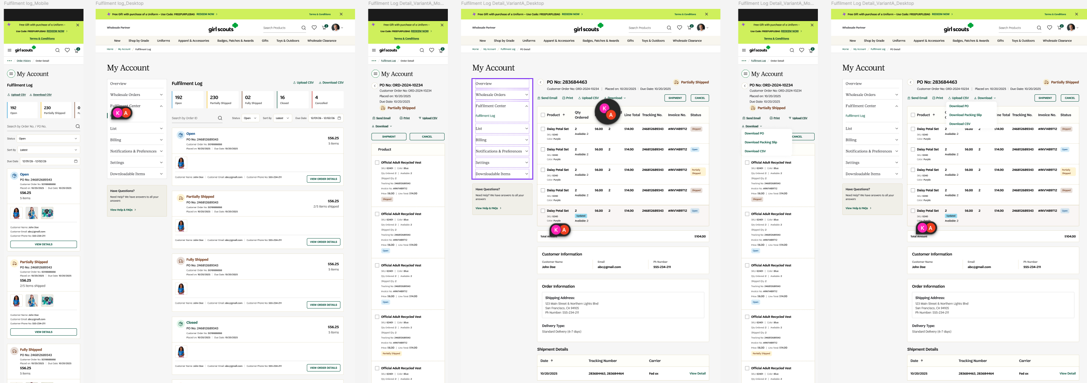

All Lists | page_type: fulfilment_log_detail | fulfilment_log_shipment

DataLayer Push

Placement
Fires on every load or SPA navigation to the All Lists view — both the initial full page load and SPA back-navigation from List Detail. Push above GTM script on full load; push on SPA route change via history API listener.

Implementation Details
Object Path | Key | Data Type | Example | Notes
root | event | string | "page_init" | Required. Fires on every load and SPA route change.
environment | env | string | "production" | Controlled values: production, staging, qa, dev
environment | site | string | "gsusa_shop" | Stable site identifier.
environment | platform | string | "web" | Controlled values: web, mweb, ios_app, android_app
environment | version | string | "1.42.0" | Release/app version.
page | page_type | string | "fulfilment_log_detail" | Controlled. Identifies All Lists SPA view. fulfilment_log_detail or fulfilment_shipment
page | page_name | string | "Fulfilment Log Detail" | Stable internal label. "Fulfilment Log Detail" or "Fulfilment Shipment"
page | path | string | window.location.pathname | Never hardcoded.
page | previous_page_path | string | null | Previous internal path. Do NOT infer from referrer.
page | referrer | string | null | document.referrer.
page | title | string | "Girl Scouts Shop" | document.title.
page | language | string | "en-US" | document.documentElement.lang.
root | user | object | {} | User details — always logged_in on account pages.
user | login_state | string | "logged_in" | Always logged_in on account pages.
user | user_id | string | "u_7f3a91c2" | Gigya ID. Never email-derived.
user | user_type | string | "returning_user" | Controlled: guest | new_user | returning_user | returned_customer.
user | customer_type | string | "vendor" | Controlled: consumer | council_administrator | vendor.
user | audience_mode | string | "wholesale_partner" | Controlled: wholesale_partner | leaders | general.
user | troop_id | string | "TR_00412" | Troop affiliation.
user | council_id | string | "CN_0087" | Council identifier.
user | em_sha256 | string | "b94d27b993..." | SHA-256 hashed email. Server-side only. Truyo consent required.
user | ph_sha256 | string | "a665a45920..." | SHA-256 hashed phone. Server-side only. Truyo consent required.
root | list_count | integer | 4 | Required. Total number of lists in All My Lists table.
root | list_names | string | "Daisy Petal Set List, Daisy Vest List..." | Optional. Comma-separated list names shown in table.

Fulfilment Log Detail
window.dataLayer = window.dataLayer || [];
window.dataLayer.push({

"event": "page_init",

"environment": {
"env": "production",
"site": "gsusa_shop",
"platform": "web",
"version": "1.42.0"
},

"page": {
"page_type": "fulfilment_log_detail",
"page_name": "Fulfilment Log Detail",
"path": window.location.pathname,
"previous_page_path": null,
"referrer": null,
"title": "Girl Scouts Shop",
"language": "en-US"
},

"user": {
"login_state": "logged_in",
"user_id": "u_7f3a91c2",
"user_type": "returning_user",
"customer_type": "vendor",
"audience_mode": "wholesale_partner",
"troop_id": "TR_00412",
"council_id": "CN_0087",
"em_sha256": "b94d27b993...",
"ph_sha256": "a665a45920..."
}

});

Fulfilment Log Shipment
window.dataLayer = window.dataLayer || [];
window.dataLayer.push({

"event": "page_init",

"environment": {
"env": "production",
"site": "gsusa_shop",
"platform": "web",
"version": "1.42.0"
},

"page": {
"page_type": "fulfilment_log_shipment",
"page_name": "Fulfilment Log Shipment",
"path": window.location.pathname,
"previous_page_path": null,
"referrer": null,
"title": "Girl Scouts Shop",
"language": "en-US"
},

"user": {
"login_state": "logged_in",
"user_id": "u_7f3a91c2",
"user_type": "returning_user",
"customer_type": "vendor",
"audience_mode": "wholesale_partner",
"troop_id": "TR_00412",
"council_id": "CN_0087",
"em_sha256": "b94d27b993...",
"ph_sha256": "a665a45920..."
}

});

Click Attribution on Feature

Add data-attributes* to clickable elements, links buttons

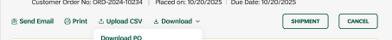

Attribute | Data Type | Requirement / Rule | Examples
data-analytics-type | string | Required. Defines the UI component style. Must use a fixed, controlled vocabulary to avoid fragmentation. | fulfilment_cta
data-analytics-location | string | Required. Defines the visual zone where the element appears. Use predefined zones only. For menus, always specify context (e.g., header vs flyout). | fulfilment_header
data-analytics-item | string | Required. Canonical identifier for the link. Use lowercase, kebab-case slugs. Must remain stable even if UI text changes. | send_email | print | Upload CSV | download
data-analytics-destination | string | Required. Target URL or action. Use relative paths for internal links. Use short action names for non-navigation actions. | /fulltiment

